Results
A total of 210 eligible gynecologists were invited to participate, of whom 169 completed the survey, yielding a response rate of 80.5%.
As all survey items were mandatory for submission, no responses were excluded for missing data; however, during data cleaning, a small number of implausible entries for age and years of postgraduate practice (e.g., values inconsistent with the respondent's stated qualifications) were identified and treated as missing rather than retained, accounting for the small amount of missingness noted for these two variables below.
The characteristics of the study sample, together with respondents' knowledge of individual low-value and evidence-based reproductive endocrinology practices, are presented below, followed by the factors associated with overall knowledge adequacy on univariable and multivariable analysis.

Table (1): basic characteristics of the studied group:
Descriptives | Age | Postgraduate years | Knowledge score
N | 167 | 160 | 169
Missing | 2 | 9 | 0
Mean | 40.2 | 16.4 | 8.37
Median | 36.0 | 12.0 | 9
Standard deviation | 10.7 | 10.6 | 3.81
Minimum | 29.0 | 6.00 | 0
Maximum | 70.0 | 46.0 | 15
Shapiro-Wilk W | 0.832 | 0.840 | 0.963
Shapiro-Wilk p | <.001 | <.001 | <.001
25th percentile | 32.0 | 8.00 | 5.00
50th percentile | 36.0 | 12.0 | 9.00
75th percentile | 46.0 | 22.0 | 12.0

Plots

Figure (1): Age
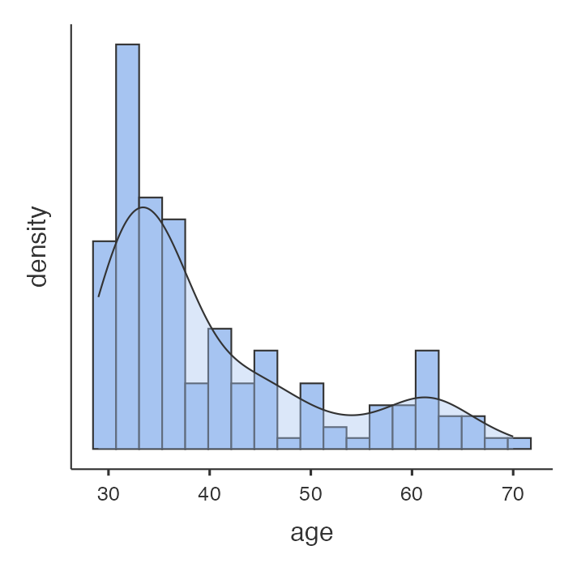

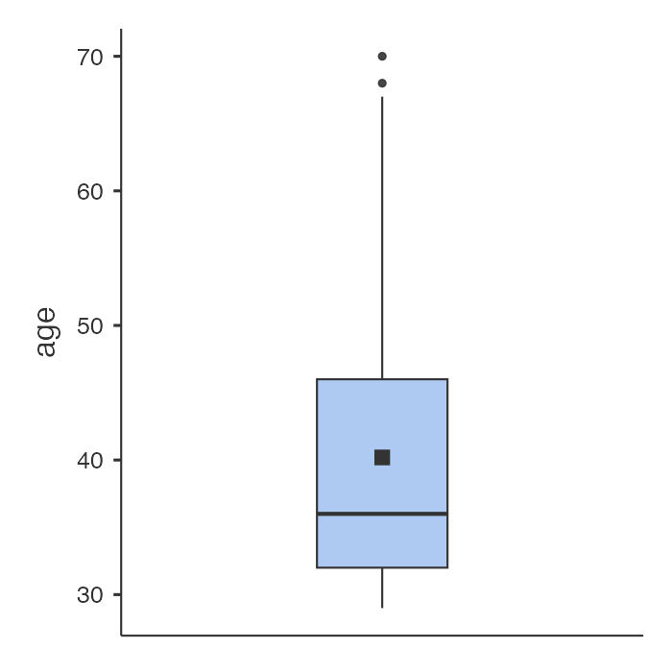
The mean age of the participants was 40.2 ± 10.7 years, while the median age was 36 years (ICQ is 32, 46). The age of participants ranged from 29 to 70 years. The median being lower than the mean suggests that a proportion of older participants increased the average age. The Shapiro–Wilk test was statistically significant (p < 0.001), indicating that age was not normally distributed; therefore, age is reported as median and interquartile range is appropriate.
Figure (2): Postgraduate years
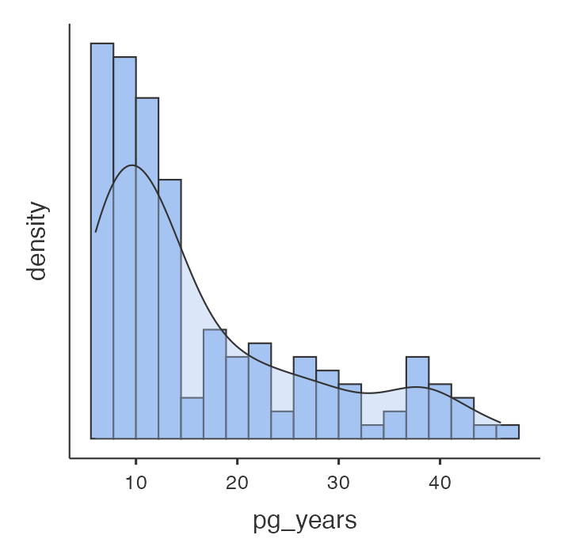
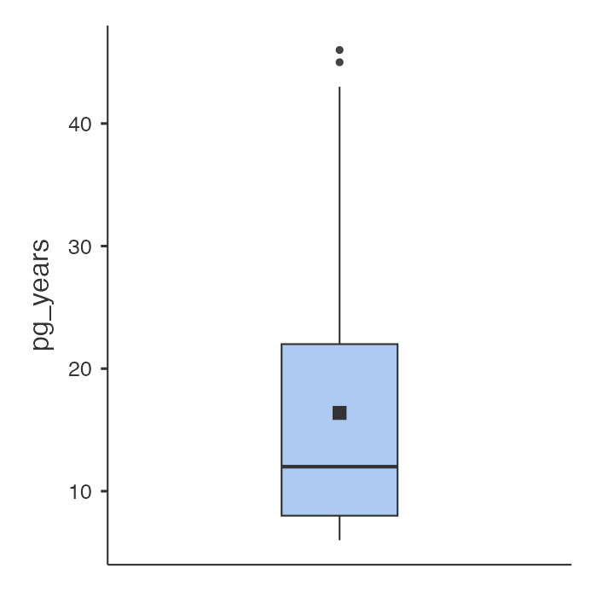
The mean postgraduate experience was 16.4 ± 10.6 years. The median was 12 years, with a range of 6–46 years and ICQ of 8 – 22 years. The variable was not normally distributed (Shapiro–Wilk p < 0.001).

Figure (3): Knowledge score
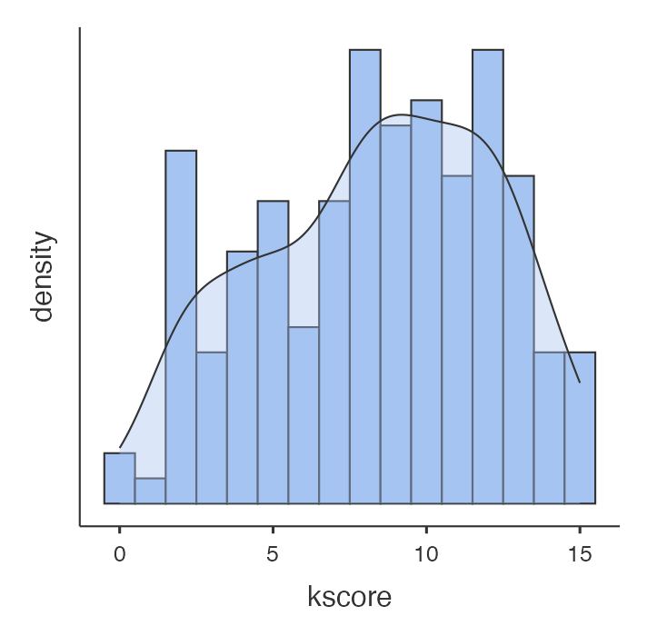
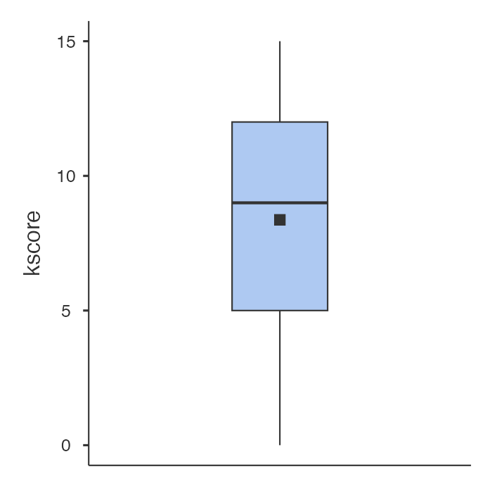
The total knowledge score ranged from 0 to 15. The mean score was 8.37 ± 3.81. The median score was 9. The interquartile range was 5–12. The knowledge scores were not normally distributed (Shapiro–Wilk p < 0.001).

Table (2) Summary Table of baseline characteristics
Characteristic | N = 169¹
age | 36 (32, 46)
Postgraduate years | 12 (8, 22)
Sex
Female | 79 (47%)
Male | 90 (53%)
Degree
1 | 97 (57%)
0 | 72 (43%)
Subspecialty
Yes | 42 (25%)
No | 127 (75%)
Provision
Yes | 142 (84%)
No | 27 (16%)
Provision _duration
Less than 5 years | 52 (37%)
Five to ten years | 42 (30%)
More than 10 years | 48 (34%)
Facility
Multi-setting | 102 (60%)
Private | 19 (11%)
Public | 48 (28%)
Guideline _access
Yes | 106 (63%)
No | 63 (37%)
¹ Median (Q1, Q3); n (%)

Most participants held the specified degree (57%), did not have a subspecialty (75%), and were involved in IVF-related provision (84%). Furthermore, 63% reported having access to clinical guidelines. The majority practiced in multiple healthcare settings (60%), reflecting a heterogeneous professional background among participants.

Table (3): Summary Table of knowledge variables
Variable | Number correct | Number total | Percent correct
Routinely administer Progesterone for luteal phase support after IVF/ICSI. | 159 | 169 | 94.1
Use the GnRH antagonist protocol for predicted high responders. | 143 | 169 | 84.6
Endometrial scratching is recommended for routine use. | 122 | 169 | 72.2
Routinely perform preimplantation genetic testing for aneuploidy screening on patients undergoing IVF | 117 | 169 | 69.2
Routinely perform Endometrial receptivity testing | 114 | 169 | 67.5
Routinely perform sperm DNA fragmentation testing | 110 | 169 | 65.1
Routinely perform hysteroscopy before IVF | 103 | 169 | 60.9
Prescribe IVIG for patients undergoing IVF, those with a history of recurrent implantation failure, or those with recurrent pregnancy loss | 101 | 169 | 59.8
Routinely perform assisted hatching on fresh embryos prior to transfer | 90 | 169 | 53.3
Prescribe leukemia inhibitory factor for patients undergoing IVF, those with a history of recurrent implantation failure, or those with recurrent pregnancy loss | 82 | 169 | 48.5
Prescribe intralipid therapy for patients undergoing IVF, those with a history of recurrent implantation failure, or those with recurrent pregnancy loss | 73 | 169 | 43.2
Prescribe lymphocyte immunization therapy for patients undergoing IVF, those with a history of recurrent implantation failure, or those with recurrent pregnancy loss | 72 | 169 | 42.6
Follow a freeze-all strategy to minimize the risk of late-onset OHSS | 51 | 169 | 30.2
Routinely recommend Low-Molecular Weight Heparin for all cases of recurrent implantation | 44 | 169 | 26
Prescribe corticosteroids for patients undergoing IVF, those with a history of recurrent implantation failure, or those with recurrent pregnancy loss | 33 | 169 | 19.5
As shown in Table 3 and Figure 4, knowledge levels varied considerably across the surveyed participants. High proportions of participants correctly identified the routine use of progesterone for luteal phase support after IVF/ICSI (94%) and the use of GnRH antagonist protocols for predicted high responders (85%). In contrast, fewer participants correctly identified recommendations regarding corticosteroids (20%), low-molecular-weight heparin (26%), and freeze-all strategies for preventing late-onset OHSS (30%). Overall, only 43% of participants demonstrated adequate knowledge (with a knowledge score of Q1 and Q2), whereas 57% had inadequate knowledge (knowledge score of Q3 and Q4).
Figure (4) Correct knowledge by item
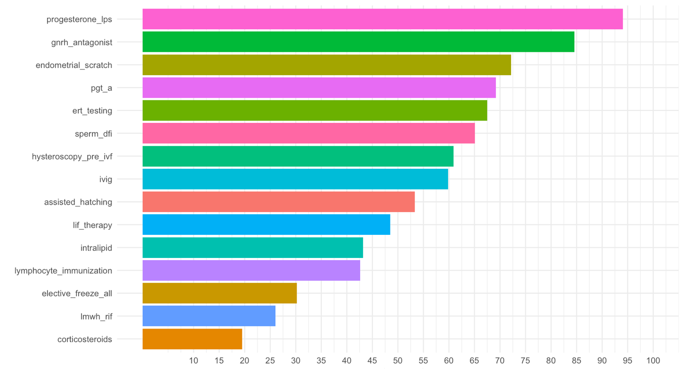

Table (6) Cross Table by sex
 | adequate |  | Total | p-value¹
 | Adequate | Inadequate
sex |  |  |  | 0.017
Female | 26 (36%) | 53 (55%) | 79 (47%)
Male | 46 (64%) | 44 (45%) | 90 (53%)
Total | 72 (100%) | 97 (100%) | 169 (100%)
¹ Pearson’s Chi-squared test

A statistically significant association was observed between sex and knowledge adequacy (p = 0.017). Male participants demonstrated a higher proportion of adequate knowledge (64%) compared with female participants (36%). This finding suggests that sex may influence knowledge levels in the study population

Table (7) Cross Table by postgraduate degree
 | adequate |  | Total | p-value¹
 | Adequate | Inadequate
degree |  |  |  | 0.016
MD or MRCOG | 49 (68%) | 48 (49%) | 97 (57%)
Master’s or Diploma | 23 (32%) | 49 (51%) | 72 (43%)
Total | 72 (100%) | 97 (100%) | 169 (100%)
¹ Pearson’s Chi-squared test

Participants holding the specified degree showed significantly higher knowledge adequacy than those without it (68% vs. 32%, p = 0.016). This finding indicates that educational qualifications may contribute positively to participants' knowledge regarding IVF practices.

Table (8) Cross Table by subspecialty degree
 | adequate |  | Total | p-value¹
 | Adequate | Inadequate
subspecialty |  |  |  | 0.066
Yes | 23 (32%) | 19 (20%) | 42 (25%)
No | 49 (68%) | 78 (80%) | 127 (75%)
Total | 72 (100%) | 97 (100%) | 169 (100%)
¹ Pearson’s Chi-squared test

Although participants with a subspecialty demonstrated a higher proportion of adequate knowledge, the association did not reach statistical significance (p = 0.066). Therefore, subspecialty status was not significantly associated with knowledge adequacy in this study.

Table (9) Cross Table by provision of care in the field in infertility
 | adequate |  | Total | p-value¹
 | Adequate | Inadequate
provision |  |  |  | 0.006
Yes | 67 (93%) | 75 (77%) | 142 (84%)
No | 5 (6.9%) | 22 (23%) | 27 (16%)
Total | 72 (100%) | 97 (100%) | 169 (100%)
¹ Pearson’s Chi-squared test

A significant association was observed between involvement in IVF-related provision and knowledge adequacy (p = 0.006). Participants actively involved in provision were more likely to demonstrate adequate knowledge than those who were not, highlighting the importance of clinical exposure in improving knowledge levels.

Table (10) Cross Table by duration of provision of care in the field in infertility
 | adequate |  | Total | p-value¹
 | Adequate | Inadequate
provision_duration |  |  |  | 0.036
Less than 5 years | 18 (27%) | 34 (45%) | 52 (37%)
Five to ten years | 20 (30%) | 22 (29%) | 42 (30%)
More than 10 years | 29 (43%) | 19 (25%) | 48 (34%)
Total | 67 (100%) | 75 (100%) | 142 (100%)
¹ Pearson’s Chi-squared test
Knowledge adequacy was significantly associated with the duration of IVF-related provision (p = 0.036). Participants with more than 10 years of experience demonstrated the highest proportion of adequate knowledge, suggesting that prolonged clinical experience contributes positively to knowledge acquisition.

Table (11) Cross Table by the healthcare facility type
 | adequate |  | Total | p-value¹
 | Adequate | Inadequate
Facility |  |  |  | 0.084
Multi-setting | 49 (68%) | 53 (55%) | 102 (60%)
Private | 9 (13%) | 10 (10%) | 19 (11%)
Public | 14 (19%) | 34 (35%) | 48 (28%)
Total | 72 (100%) | 97 (100%) | 169 (100%)
¹ Pearson’s Chi-squared test

No statistically significant association was found between healthcare facility type and knowledge adequacy (p = 0.084). Although participants practicing in multiple settings tended to demonstrate better knowledge levels, the difference was not statistically significant.

Table (12) Cross Table by access to guideline in the place of practice
 | adequate |  | Total | p-value¹
 | Adequate | Inadequate
guideline_access |  |  |  | 0.3
Yes | 42 (58%) | 64 (66%) | 106 (63%)
No | 30 (42%) | 33 (34%) | 63 (37%)
Total | 72 (100%) | 97 (100%) | 169 (100%)
¹ Pearson’s Chi-squared test
Access to clinical guidelines was not significantly associated with knowledge adequacy (p = 0.30). Participants with and without guideline access demonstrated comparable levels of adequate knowledge, suggesting that guideline availability alone may not be sufficient to influence knowledge levels.

Tabel 13 Association between total knowledge score and respondent characteristics
Characteristic | N = 169¹ | p-value²
Degree |  | <0.001
MD or MRCOG | 10 (7, 12)
Master’s or Diploma | 7 (5, 10)
Subspecialty |  | 0.035
Yes | 10 (8, 12)
No | 8 (5, 11)
Provision duration |  | 0.040
Less than 5 years | 8 (5, 11)
Five to ten years | 9 (8, 11)
More than 10 years | 10 (8, 12)
Provision |  | <0.001
Yes | 9 (7, 12)
No | 4 (2, 8)
Facility |  | 0.056
Multi-setting | 9 (7, 12)
Private | 6 (4, 12)
Public | 8 (4, 10)
Guideline access |  | 0.6
Yes | 9 (5, 12)
No | 9 (6, 11)
¹ kscore: Median (Q1, Q3)
² Wilcoxon rank sum test; Kruskal-Wallis rank sum test

Consistent with the findings above, the total knowledge score itself varied significantly by several characteristics. Respondents with an MD or MRCOG scored higher (median 10, IQR 7–12) than those with a Master’s degree or diploma (median 7, IQR 5–10; p < .001). Respondents who provided fertility-related care scored substantially higher (median 9, IQR 7–12) than those who did not (median 4, IQR 2–8; p < .001), and scores rose progressively with longer duration of provision, from a median of 8 (IQR 5–11) for under 5 years, to 9 (IQR 8–11) for 5–10 years, to 10 (IQR 8–12) for more than 10 years (p = .040). Respondents with a subspecialty in reproductive endocrinology and infertility also scored higher (median 10, IQR 8–12) than those without (median 8, IQR 5–11; p = .035). Scores did not differ significantly by practice setting (multi-setting median 9, IQR 7–12; private median 6, IQR 4–12; public median 8, IQR 4–10; p = .056) or by guideline access (access median 9, IQR 5–12; no access median 9, IQR 6–11; p = .6).

Tabel 14 Multivariable Logistic Regression
Characteristic | OR | 95% CI | p-value
Age | 0.92 | 0.74, 1.12 | 0.4
Postgraduate years | 1.06 | 0.87, 1.32 | 0.6
Sex
Female | — | —
Male | 0.56 | 0.28, 1.13 | 0.11
Degree
MD or MRCOG | — | —
Master’s or Diploma | 1.41 | 0.66, 3.01 | 0.4
Subspecialty
Yes | — | —
No | 1.70 | 0.76, 3.86 | 0.2
Provision
Yes | — | —
No | 3.06 | 1.11, 9.90 | 0.041
Abbreviations: CI = Confidence Interval, OR = Odds Ratio
On multivariable logistic regression adjusting for age, years of postgraduate practice, sex, degree, subspecialty in reproductive endocrinology and infertility, and provision of fertility-related care, the only independent predictor was provision of care itself: respondents who did not provide such care had roughly three times higher odds of inadequate knowledge relative to those who did (OR 3.06, 95% CI 1.11–9.90, p = .041). No other variable reached statistical significance after adjustment, including age (OR 0.92, 95% CI 0.74–1.12, p = .4), years of practice (OR 1.06, 95% CI 0.87–1.32, p = .6), sex (male vs female: OR 0.56, 95% CI 0.28–1.13, p = .11), degree (OR 1.41, 95% CI 0.66–3.01, p = .4), and subspecialty status (OR 1.70, 95% CI 0.76–3.86, p = .2).

Table 15 Multivariable Linear Regression
Characteristic | Coefficient | 95% CI | p-value
age | 0.19 | -0.15, 0.52 | 0.3
Postgraduate years | -0.19 | -0.54, 0.15 | 0.3
Sex
Female | — | —
Male | 0.59 | -0.58, 1.8 | 0.3
Degree
MD or MRCOG | — | —
Master’s or Diploma | -1.2 | -2.4, 0.09 | 0.068
Subspecialty
Yes | — | —
No | -0.99 | -2.4, 0.39 | 0.2
Provision
Yes | — | —
No | -3.0 | -4.5, -1.4 | <0.001
Abbreviation: CI = Confidence Interval
A parallel multivariable linear regression using the continuous knowledge score as the outcome confirmed provision of fertility-related care as the sole independent predictor: respondents who did not provide such care scored on average 3.0 points lower than those who did (coefficient −3.0, 95% CI −4.5 to −1.4, p < .001), after adjustment for age, years of practice, sex, degree, and subspecialty status. None of the remaining covariates were independently associated with knowledge score: age (coefficient 0.19, 95% CI −0.15 to 0.52, p = .3), years of practice (coefficient −0.19, 95% CI −0.54 to 0.15, p = .3), sex (coefficient 0.59, 95% CI −0.58 to 1.8, p = .3), degree (coefficient −1.2, 95% CI −2.4 to 0.09, p = .068), and subspecialty status (coefficient −0.99, 95% CI −2.4 to 0.39, p = .2).

